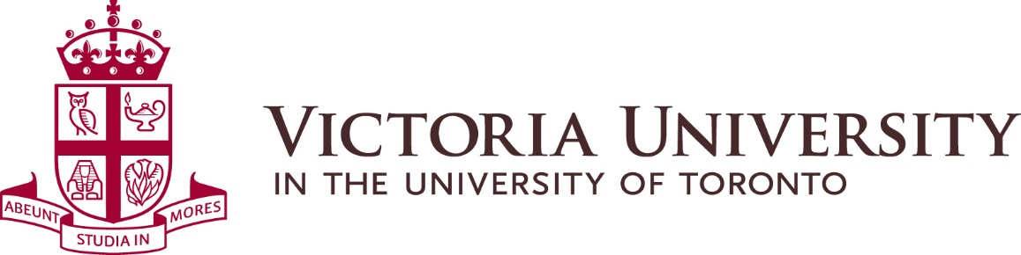

MINUTES OF KICKOFF MEETING OF THE
SUSTAINABILITY COMMITTEE
Held on October 11, 2018 from 10:00 am to 11:30 am
Regents Room

Present: Jared Connoy, Sustainability Commissioner
Victoria Silva, Sustainability Co-Chair
Vikas Mehta, Director Physical Plant
Shainiya Balachandran, Dean’s Office
Christina Alcena, Dean’s Office (alternate)

Absent: Ray DeSouza, Bursar and CAO
Ibrahim Hasan, Building President Representative

Recording Secretary: Véronique Morris, Physical Plant

Introduction:
Vikas Mehta initiated a round table introduction of all participants in attendance and reiterated Senior Management support for this Committee. Other Committee members expressed their commitment towards sustainability, especially in the residences.

Vikas Mehta had invited Ron Saporta, COO at UfT St. George Campus Facilities, to attend the meeting who unfortunately could not be here. He and Prof. John Robinson, Presidential Advisor on the Environment, Climate Change and Sustainability at UfT, will be invited to attend the next meeting. Discussion with UfT St. George Campus related to benchmarking Victoria University and UfT’s residences, project that would be undertaken internally by UfT and would encourage student engagement in sustainability.

Previous sustainability initiatives:
The list of previous sustainability initiatives distributed at the meeting was reviewed. The Committee was informed that the installation of bottle filling stations continues and all buildings will be equipped with at least one station within the next 18 months.

Waste diversion/possible compost:
Victoria University last waste audit rates its waste diversion at 63%, above the province’s guidelines. The University aims at reaching 75% waste diversion.

Issues regarding composting were discussed at length: compost collection is very strict and challenging; the City does not pick up contaminated compost.

Future sustainability initiatives:
The Committee was informed that there will be a tab designated for sustainability on the new web site that will invite students to comment online.

The University will be working with consultants to create electrical and mechanical design standards to be posted on the new web site. The University is also considering sub-metering of energy use (mechanical and electrical) all buildings in the future.

Shainiya Balachandran confirmed that Annesley Hall is not composting this year. Challenges encountered last year concerned contamination of bins, which are landfill waste when contaminated. Discussion around communication to students and education followed, as well as who is responsible for the bins. Shainiya Balachandran supported the idea of good signage as a learning tool to compost and recycle properly. Victoria Silva concurred that signage on top of the bins is very helpful. Annesley Hall was determined to be the best residence to initiate composting.

Victoria Silva proposed a mandatory training during orientation on composting, semi-regular floor meetings, and green reps on every floor. Dons would act as green representatives to educate students. Floor councils would be excellent representatives as well. Smaller groups strategy was favoured.

Vikas Mehta proposed to meet with green representatives at the beginning of the school year. Housekeeping staff involvement is recommended to monitor the program for bug or pest prevention.

Jared Connoy suggested improving communication about the composting initiative, as students were not aware of it last year. Labels created by students last year should be used again. Shainiya Balachandran suggested the VUSAC web site as a good tool to communicate.

Jared Connoy asked the Sustainability Committee to pass on the Sustainability Commission concerns about making changes in Food Services. It was noted that Ancillary Services is currently undergoing internal changes. Transparency and plain language are a major focus for students. Support from the University’s administration is important to students.

Victoria Silva asked if students living in other residences could bring their compost to Annesley Hall? Prospects of composting in residences need to be discussed further in future sustainability meeting.

The Committee reviewed current sustainability initiatives in the Burwash Dining Hall such as composting, “Trayless Tuesday” and the use of cutlery. Caffeinds is also engaged in sustainability and no longer uses plastic sticks, for instance.

Shainiya Balachandran informed the Committee that the new menu this year is offering less meat and more vegetarian options.

Vikas Mehta indicated that he will push for the proposed redevelopment of Northrop Frye Hall to be a net zero project and will investigate geothermal initiatives for campus.

Comments and questions:
Students asked that the University release a sustainability plan with targets, dates and goals to be posted online. A recent survey indicated that students were not satisfied with sustainability at Victoria University. Concerns were around food services activities, composting and waste diversion. The University will continue to work with all stakeholders to improve our waste diversion rates.

Victoria Silva relayed a request from the Sustainability Commission about adding cigarette butt collectors on campus. Vikas Mehta responded this can be viewed to promote smoking and our objective is to promote a smoke free campus.

Vikas Mehta to send photos to Committee from a Carleton University pilot project on waste diversion at one of their food courts.
Action: completed in an email sent on Oct. 12, 2018 by Vikas Mehta.

Christina Alcena offered to promote upcoming external sustainable events organized by students.

Committee members were encouraged to bring ideas to the Committee in between meetings.

Committee members are encouraged to bring up items to the agenda as much in advance as possible, for distribution by end of January 2019.

Next meeting:
The next meeting has been set for the week of February 25, 2019 – time and place TBD.

