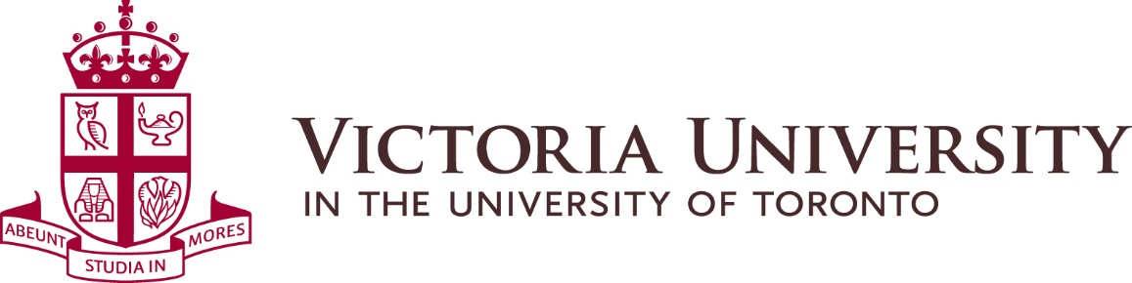

MINUTES OF MEETING OF THE
SUSTAINABILITY COMMITTEE
Held on October 18, 2019 from 10:00 am to 11:30 am
NFH 205

Present: Aminah Attar, Sustainability Commissioner
Leila Tjiang, Sustainability Co-Chair
Lauren Allison, Building President Representative - Burwash Hall
Tara Costello, Building President Representative - Annesley Hall
Vikas Mehta, Director Physical Plant
Lyndon Nobre, Director of Business and Ancillary Services
Shainiya Balachandran, Dean’s Office
Christina Alcena, Dean’s Office (alternate)

Guest speaker: Ron Saporta, COO Property Services & Sustainability, U of T
and Jennifer Puskar and Adriana Dossena from the Sustainability Office.

Absent: Ray DeSouza, Bursar and CAO

Recording Secretary: Véronique Morris, Physical Plant

Introduction:
Vikas Mehta initiated a round table introduction of all participants and introduced guest speaker, Ron Saporta, COO Property Services & Sustainability at the University of Toronto.

Guest Speaker:
Ron Saporta presented the newly released Low-Carbon Action Plan for 2019-2024. U of T’s goal is to cut greenhouse gas emissions by 37 per cent from 1990 levels by the year 2030. Twelve projects have been completed in one year as part of a tri-campus greenhouse gas reduction; the plan looks at three angles: 1. consuming less energy, 2. producing cleaner energy and 3. distributing that energy more efficiently.

The five-year plan aims to bring U of T 80 percent closer to its 2030 target by the year 2024. For that, U of T is taking on energy projects with its researchers and encouraging joint effort to reduce carbon emission. Federated universities fall under the U of T carbon foot print.

Ron Saporta explained that an organization’s greenhouse gas emissions can be classified into three categories:
- Scope 1: direct emissions from sources owned or controlled by the organization, like the burning of natural gas to generate steam for heating and cooling.
- Scope 2: indirect emissions from the generation of purchased energy, like purchasing and consuming electricity from a utility provider.
- Scope 3: indirect emissions that occur in the value chain of the organization, such as emissions associated with travel (not included in scope 2 nor in U of T’s plan)

Ron Saporta encouraged both institutional and individual initiatives such as turning off lights, replacing interior and exterior lights with LEDs, or organizing competitions in residences.

A copy of the Plan can be obtained at: https://www.fs.utoronto.ca/wp-content/uploads/2019/10/2019-10-04_LowCarbonActionPlan_V22_Spread_Web.pdf

A series of Questions and Answers followed:
Shainiya Balanchandran asked to see metrics on energy consumption, which will be addressed within the annual report.

A discussion followed regarding the communication to the Vic community that all changes, even small, are important and make a difference.

Aminah Attar asked what funding Victoria University is getting from U of T about energy-related projects. Vikas Mehta responded that the two organizations are in on-going discussions not on funding but discussions on collaboration, sharing information related to sustainability initiatives.

Vikas Mehta recommended Natural Resources Canada at https://www.nrcan.gc.ca/home as a good resource about energy efficiency.

Minutes:
Motion to approve the minutes of the previous meeting held on February 27, 2019. Carried.
Business arising from previous meeting:
Vikas Mehta presented the first annual report for the period of October 2018 to September 2019 (attached).

Victoria University conducted several initiatives with a focus on energy reduction such as the installation of LED lights with motion sensors, the window refurbishment in Lillian Massey building; this building has already seen a 15% to 20% reduction in hydro and heating costs.

The installation of bottle filling stations is complete in:
- EJ Pratt Library, ground level.
- Emmanuel College, basement level.
- Victoria College, basement level.
- Isabel Bader Theatre, ground level.
- Burwash Dining Hall, servery, 1st floor.
- Goldring Student Centre, commuter lounge, basement level.

Continuing to other facilities in the future.

Future sustainability initiatives:
Victoria University is planning to replace the windows at Burwash Hall residences in the coming years. Vikas Mehta explained that heritage buildings require processes to follow such as obtaining permits/approvals from Heritage Preservation Services whenever there is a major change in heritage building.

Victoria University is planning to change the exterior lamp posts on campus with LED fixtures and is also investigating the possibility of installing solar panels at some of its buildings.

Victoria University has applied for funding at the Natural Resources Canada for up to $100,000 to conduct an energy audit for benchmarking purpose; decision to be announced in the Fall.

Vikas Mehta remarked that future capital projects will have a sustainable component.

Lyndon Nobre communicated a new initiative from Food Services to measure waste reduction, with the creation of a waste log that will document traffic and weigh waste. The data will help plan sustainable initiatives. Furthermore, Ned’s Café will introduce compostable take-away containers. Lyndon will present the cost of these initiatives at the next committee meeting. Shainiya reminded the Committee that “Tray-Less” Tuesday was implemented in the past in the Dining Hall.

Lyndon Nobre suggested installing a “suggestion box” in food services areas, which could be done via an app in the future, and interactive boards. Lyndon emphasized the importance of education in the process and would be happy to meet on a monthly basis with a sub-committee to increase communication.

Leila Tjian would like to see more interactive ways to show students how much food is wasted; one suggestion is better signage.

Tara Costello observed that the photos on the recycling boxes in the residences are too small and confusing. Victoria University to install larger signage in Rowell Jackman Hall, as shown in the pilot project conducted by Carleton University on waste diversion at one of their food courts. Tara asked how we separate bags when they are taken out of the recycling boxes. Vikas Mehta responded that we have different bags for different recycling.

Aminah Attar expressed her satisfaction about the future sustainability tab on the new web site and hopes to see metrics; Aminah offered to help with the web page. Christina Alcena suggested that the web site be demonstrated to the Sustainability Committee before going live. Vikas Mehta noted that only projects that are sustainable will be posted on the web site.

Aminah asked how the strategic planning, currently undergoing by the President’s Office, relates to sustainability. Vikas Mehta responded that the creation of Mechanical, Electrical and Construction Design standards for all new construction and major renovations ties up with the plan.

Aminah Attar questioned what the application process for funding is. Vikas Mehta responded that Physical Plant conducts feasibility studies of proposed sustainability-related initiatives/projects to be presented to the Bursar for funding approval.

Leila Tjiang inquired about the detail of information received on hydro billings, to which Vikas Mehta responded that the information is basic.

Vikas Mehta and Lyndon Nobre agreed to conduct a pilot project together on waste diversion.

Leila Tjian and Aminah Attar presented the “Vic Zero Waste: Our Mission” recycling education plan to the Committee, to be launched soon; this pilot project aims to promote education to students and residents related to organic and recycling waste streams. Vikas Mehta recommended the Sustainability Commission choose one floor of a residence to start and be mindful of issues such as cross-contamination. Aminah Attar to follow up with Vikas Mehta to implement the pilot project.

Next meeting:
The next meeting will be scheduled in early 2020, time and place TBD.

