Request to Hire Form

Contents
Overview
Registration
Request to Hire Form

Overview

Overview | Below outlines the steps for accessing and submitting a Request to Hire Form. Please note this request form is intended for appointed positions only. As well, please refer to the Hiring Guidelines available on the HR site.

Registration

- To submit a request, please visit and login: https://hr.vicu.utoronto.ca/Secure/RequestToHire

- New users will be required to register as a new user (see image below):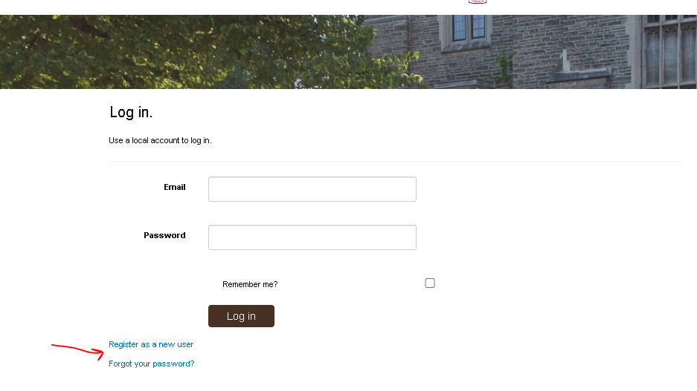
- You will be required to enter your UTORid, e-mail address and a new password.
- Your new password must include:
- at least 12 characters
- at least 1 non letter or digit character
- at least 1 digit ('0'-'9').
- Click “register” - the system will send an e-mail to confirm the registration.
- Check your mailbox and click on the confirmation link seen in that e-mail to complete the registration.
Request to Hire Form

- To submit a request, log into the application at: https://hr.vicu.utoronto.ca/Secure/RequestToHire
- Fill out all required fields (see below image)

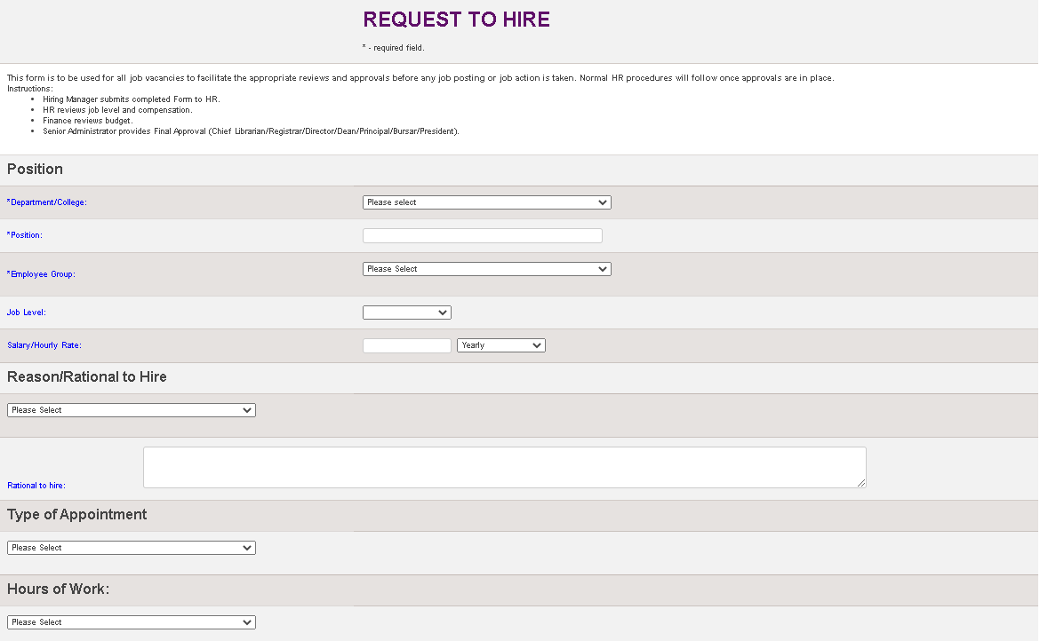
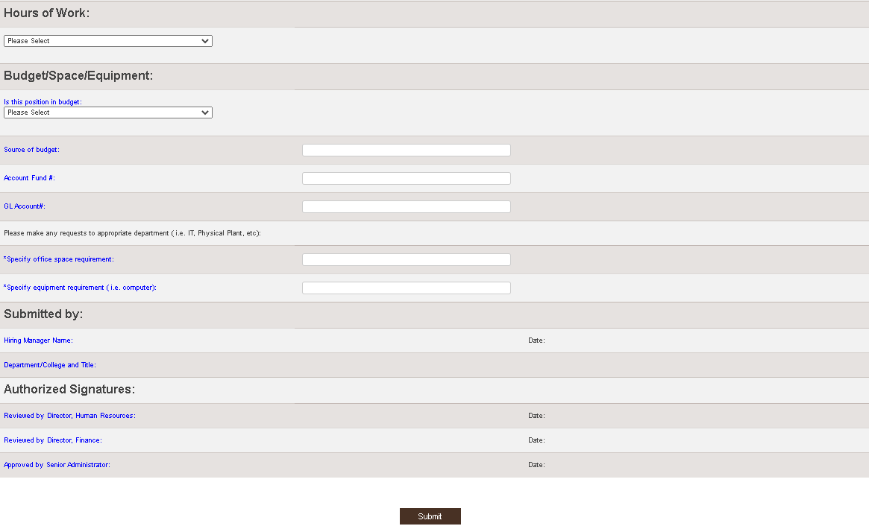
- Click Submit. Your request will follow the approval workflow, outlined in the Hiring Guidelines available on the HR site.

